**University of Essex Online**

**Network and Information Security Management March 2022 B**

**Development Team Project:**  
 **Executive Summary**

**Target**: [https://loadedwithstuff.co.uk](https://loadedwithstuff.co.uk/)

**Domain**: Ecommerce Website

Team 1: Chan Kei Yiu Yvone, HungWei Lin, Thien Liu, Yusuf Fahry

21 May 2022

Introduction 3

Executive Summary 4

Assessment Execution Schedule 5

System Characteristics 7

Ports and Services Scanning 8

Summary of Findings 8

Assessment Methodology 10

Assessment Tools 11

Threat Modelling 11

Detailed Findings 13

Security Standards Compliance Analysis 17

GDPR Compliance Analysis 18

1. Privacy Policy 18

2. Website Security 18

3. TLS Encryption 19

4. Cookie Protection 20

5. Cookie Disclaimer 20

PCI DSS Compliance Analysis 20

Conclusion 21

References 22

Appendix 23

Low and Informational threats 24

Appendix A – Nmap Scan Result 35

Appendix B – POP3 Cleartext Logins Permitted 36

Appendix C – SQLMap scan result 37

Appendix D – Nikto scan result 38

Appendix E – CPanel is visible to the public 39

Appendix F – Webmail is visible to the public 40

Appendix G – Burp Suite scan result 41

Appendix H - Absence of Anti-CSRF Tokens 42

Appendix I - Content Security Policy (CSP) Header Not Set 43

Appendix J - Vulnerable JS Library 44

Appendix K - Application Error Disclosure 45

Appendix L - Cookie without SameSite Attribute 46

Appendix M - Server Leaks Information via "X-Powered-By" HTTP Response Header Field(s) 47

Appendix N - Timestamp Disclosure 48

Appendix O - Port scanning result from Metasploit 49

# **Introduction**

Online commerce giant eBay announced in March of 2014 that hackers have stolen encrypted passwords and other credential information of their 145 million users. Although the breach did not involve the credit card number or financial information, the incident has caused a negative impact on eBay's reputation, and its share dropped 12.94% after the attack. (Andrea, 2014)

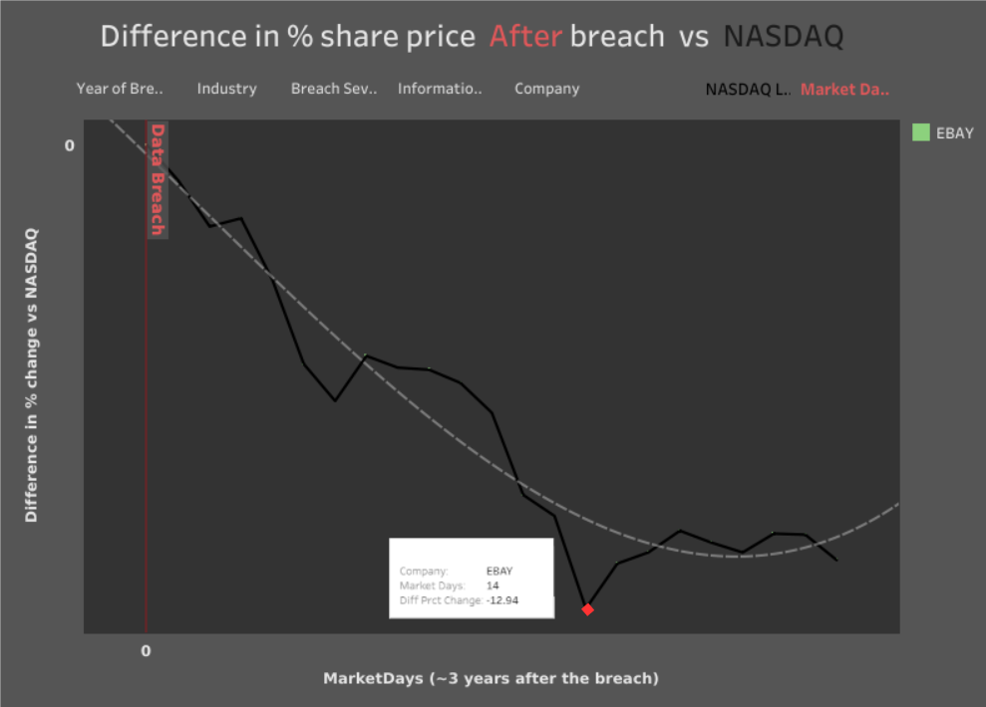

Figure 1: Difference in % share price after breach (Tableau ,2021)

As e-commercial websites have increasingly become the common target of hacking activities, it is necessary for companies to follow and adopt the best practice to minimize the vulnerabilities and risks of their web applications. 'Through risk assessment, we can understand the security situation and take targeted security measures which control the risk within an acceptable range.' (Lai Z. et al., 2016).

# **Executive Summary**

This report gives the detailed results from a risk assessment performed on the ecommerce website <https://loadedwithstuff.co.uk>. The assessment focused on identifying threats and vulnerabilities applicable to the web application and the services running on the webserver. This evaluation also offers recommendations of risk mitigation to each of the identified system vulnerabilities. Furthermore, security standards compliance was simultaneously evaluated and suggestions for full compliance were also included.

## **Assessment Execution Schedule**

Figure 2 shows the complete timeline from receiving the requirement until this report is ready to deliver. The illustration also highlights different stages when the security assessment was being carried out.

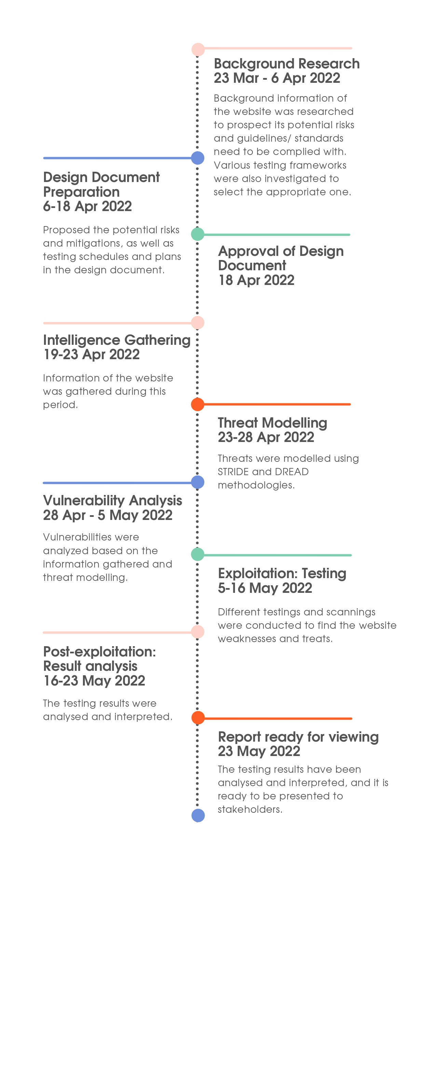

Figure 2. Timeline of the whole project

## **System Characteristics**

With the use of several network utilities, the following information can be retrieved from the website at the time the assessment was performed.

|  |  |
| --- | --- |
| **Domain Name** | loadedwithstuff.co.uk |
| **Top Level Domain** | UK (United Kingdom) |
| **IP Address** | 68.66.247.187 |
| **DNS Server** | ns1.a2hosting.com  ns2.a2hosting.com  ns3.a2hosting.com  ns4.a2hosting.com |
| **ASNN** | AS55293 |
| **Geolocation** | US (United States), MI, Michigan, 48106 Ann Arbor |
| **Reverse DNS** | 68.66.247.187.static.a2webhosting.com |
| **HTTP Server** | Apache |
| **PHP** | 7.4.29 |
| **Software** | Loaded Commerce Community Edition v6.6  jQuery 1.12.4  Bootstrap 3.3.6, 3.3.7 |
| **Email** | sales@loadedwithstuff.co.uk |
| **Hosts** | autodiscover.loadedwithstuff.co.uk:68.66.247.187  cpanel.loadedwithstuff.co.uk:68.66.247.187  cpcalendars.loadedwithstuff.co.uk:68.66.247.187  cpcontacts.loadedwithstuff.co.uk:68.66.247.187  mail.loadedwithstuff.co.uk:68.66.247.187  webdisk.loadedwithstuff.co.uk:68.66.247.187  webmail.loadedwithstuff.co.uk:68.66.247.187  www.loadedwithstuff.co.uk:68.66.247.187 |

## **Ports and Services Scanning**

The following network ports and the associated services were discovered during the assessment. It is recommended to review and understand what processes or protocols are using the ports. Any ports that the system admins do not recognize might indicate a security vulnerability (SecurityScorecard, 2020).

|  |  |  |  |
| --- | --- | --- | --- |
| **PORT** | **STATE** | **SERVICE** | **VERSION** |
| 21/tcp | open | ftp | Pure-FTPd |
| 25/tcp | open | smtp? |  |
| 53/tcp | open | domain | ISC BIND 9.11.4-P2 (RedHat Enterprise Linux 7) |
| 53/udp | open | domain |  |
| 80/tcp | open | http | Apache httpd (W3 Total Cache/0.9.4.6.4) |
| 110/tcp | open | pop3 | Dovecot pop3d |
| 143/tcp | open | imap | Dovecot imapd |
| 443/tcp | open | ssl/http | Apache httpd (W3 Total Cache/0.9.4.6.4) |
| 465/tcp | open | ssl/smtp | Exim smtpd 4.94.2 |
| 587/tcp | open | smtp | Exim smtpd 4.94.2 |
| 993/tcp | open | ssl/imap | Dovecot imapd |
| 995/tcp | open | ssl/pop3 | Dovecot pop3d |
| 2525/tcp | open | smtp | Exim smtpd 4.94.2 |
| 3306/tcp | open | mysql | MySQL 5.5.5-10.3.23-MariaDB-cll-lve |
| 5432/tcp | open | postgresql | PostgreSQL DB 9.6.0 or later |
| 6556/tcp | filtered | Checkmk-agent |  |
| 7822/tcp | filtered | unknown |  |

## **Summary of Findings**

* SQL Injection testing was performed using SQLMap, the result shows that none of the tested parameters appear to be injectable. (Refer to Appendix C for the detailed log).
* During the testing period, it was observed that the website will block an IP address if it detects unusual traffic coming from that IP address. This states that an effective DDOS prevention mechanism has been implemented to protect the website.
* Besides the good indicators, the assessment has resulted in several security threats as can be summarized below. No issues of high impact were found. Six medium impact and nine low impact issues were identified (Chart 2).

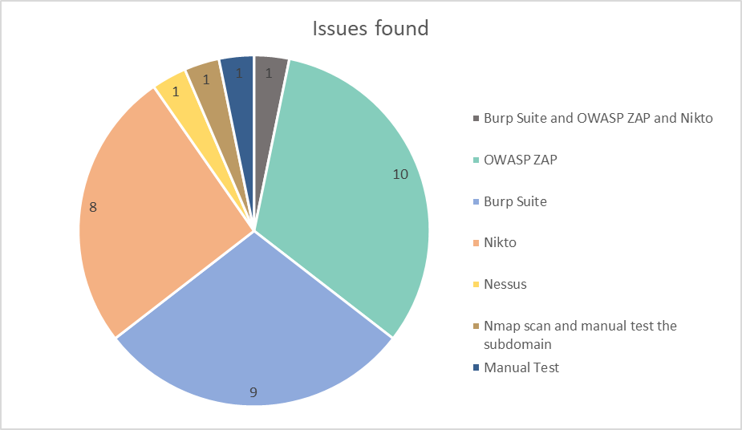

Chart 1: Issues found by tools

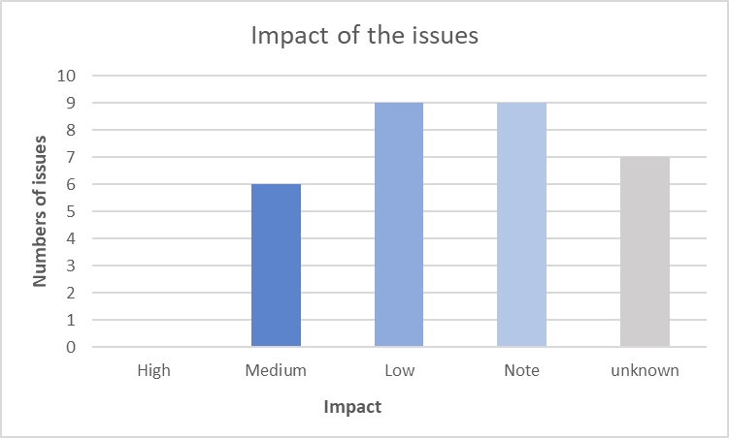

Chart 2: Impact of the issues

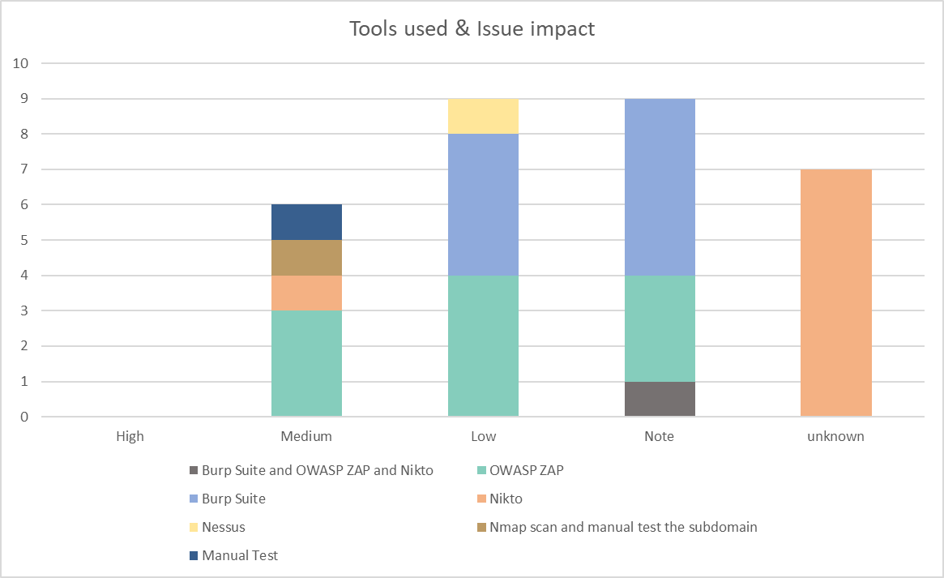

Chart 3: Tools used and Issue impact

# **Assessment Methodology**

**Assessment Tools**

Following PTES guidelines, various tools were used to carry out the testing. The rationale for choosing these tools is listed below.

|  |  |  |
| --- | --- | --- |
| **Testing Phase** | **Tool** | **Ranking/Popularity** |
| **Pre-Engagement Interaction**  **Information Gathering** | nslookup, whatweb, dig, whois | These popular tools are widely used and recommended by professionals and organizations in the cybersecurity industry. |
| **Vulnerability Analysis**  **Exploitation**  **Post-Exploitation** | OWASP Zap | Ranked #6 by PeerSpot, OWASP Zap is also one of the most popular tools used since it is free, provides automated attack operation and the results are interpreted comprehensively. |
| Burp Suite | PeerSpot’s top 10 tools in Fuzz Testing, AST, and app security tools. Having customer from big companies such as Google, Amazon, and NASA. |
| Qualys SSL Labs | With a rating of 4.4 on Garter Peer Insights, it provides automated scanning, up-to-date threat & vulnerabilities database, and automated asset monitoring. |
| Nmap | Having a score of 9.4 in TrustRadius, it provides a complete automated network scan. Popular among sysadmins. |
| Nikto | An open-source tool that’s being used and scaled up in Metasploit and Burp Suite. |

## **Threat Modelling**

Finding vulnerabilities is vital but estimating the associated risk to the business is just as important (OWASP, N.D.). The determination and categorization of threats during the assessment process have employed OWASP’s threat modelling process and risk rating since OWASP inherits STRIDE and DREAD for this purpose. The methodology details are available at:

* <https://owasp.org/www-community/Threat_Modeling_Process#determine-and-rank-threats>
* <https://owasp.org/www-community/OWASP_Risk_Rating_Methodology>

The risk severity of each finding can be summarized in the table below, where **Risk Severity** = **Likelihood** * **Impact**.

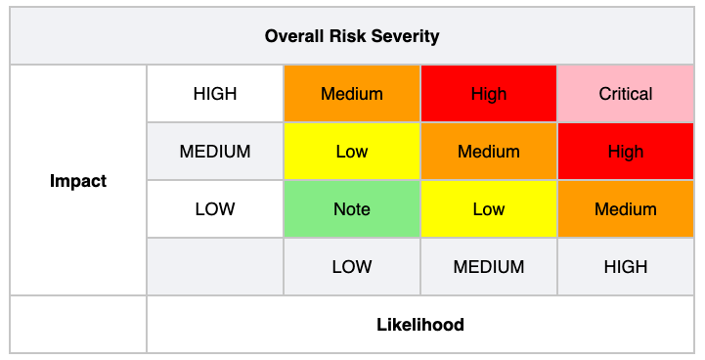

Figure 3. Risk Severity (OWASP, n.d)

# **Detailed Findings**

Six issues with the most impacts are listed in this section. They can be roughly categorized into exposure of internal resources, inappropriate settings, and vulnerable design or libraries (Chart 3). The full list of issues with low or informational impact can be found in the Appendix. It is recommended to update the related settings and components to minimize possible threats.

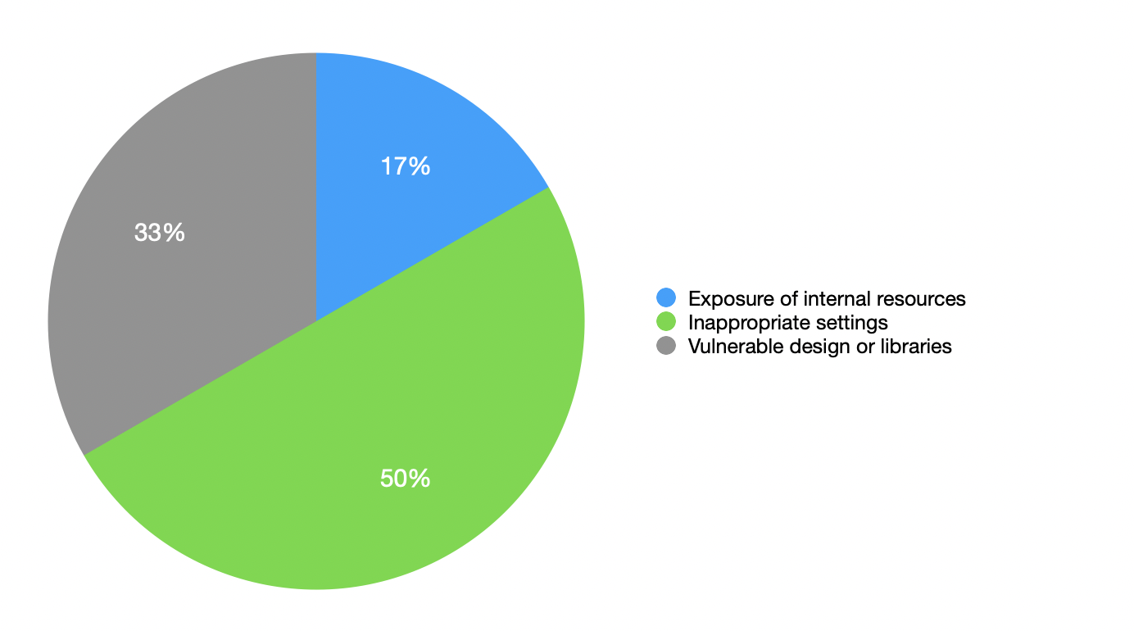

Chart 4: Threat by categories

|  |  |
| --- | --- |
| Threat | **Server vulnerable to BREACH attacks** |
| Description | The Content-Encoding header is set to ‘deflate’ which may be vulnerable to BREACH attacks |
| Risk Severity | Medium |
| Recommendation | Disabling the compression-only if the referrer is not the own application |
| Original Scan Result | Appendix D |
| Tool | Nikto |
| Reference | https://nvd.nist.gov/vuln/detail/CVE-2013-3587 |

|  |  |
| --- | --- |
| Threat | **cPanel and Webmail are visible to the public** |
| Description | cPanel is supposed to be only accessible by administrators to manage the website content and users. Webmail is supposed to be only accessible by internal users. They should not be visible to the public as it may be vulnerable to Bruce Force Attack or Broken Access Control.  URLs: <https://cpanel.loadedwithstuff.co.uk/>, <https://webmail.loadedwithstuff.co.uk/> |
| Risk Severity | Medium |
| Recommendation | Restrict the public users to access these URLs or automatically navigate them back to the homepage |
| Original Scan Result | Appendix E, Appendix F |
| Tool | Nmap scan and manually test the subdomain |
| Reference | <https://owasp.org/Top10/A01_2021-Broken_Access_Control/>  <https://owasp.org/www-community/attacks/Brute_force_attack> |

|  |  |
| --- | --- |
| Threat | **Absence of Anti-CSRF Tokens** |
| Description | CSRF attacks cause the victim users to carry out an action unintentionally. If the compomised user has a privileged role within the application, then the attacker might be able to take full control of all the application’s data and functionality. (PortSwigger, n.d) |
| Risk Severity | Medium |
| Recommendation | * Generate and use a long and hard-to-guess CSFR token. * Strictly validate user’s session in every case before the relevant action is executed (PortSwigger, n.d). * Utilise the built-in CSRF protection of the web frameworks if available. * Follow the potential mitigations suggested by MITRE (n.d) to handle improper encoding or escaping of output. More details at: <https://cwe.mitre.org/data/definitions/116.html>. |
| Original Scan Result | Appendix H |
| Tool | OWASP ZAP |
| Reference | <http://projects.webappsec.org/Cross-Site-Request-Forgery>  <http://cwe.mitre.org/data/definitions/352.html> |

|  |  |
| --- | --- |
| Threat | **Content Security Policy (CSP) Header Not Set** |
| Description | Content Secure Policy is used to enhance the security of the resources such as Javascript, CSS. The CSP was designed to reduce the Cross Site Scripting (XSS) attacks. (Foundeo Inc, 2015) |
| Risk Severity | Medium |
| Recommendation | Ensure that the servers are configured to set the Content-Security-Policy header. CSP directive reference is accessible at: <http://content-security-policy.com> |
| Original Scan Result | Appendix I |
| Tool | OWASP ZAP |
| Reference | <https://developer.mozilla.org/en-US/docs/Web/Security/CSP/Introducing_Content_Security_Policy>  <https://cheatsheetseries.owasp.org/cheatsheets/Content_Security_Policy_Cheat_Sheet.html>  <http://www.w3.org/TR/CSP/>  <http://w3c.github.io/webappsec/specs/content-security-policy/csp-specification.dev.html>  <http://www.html5rocks.com/en/tutorials/security/content-security-policy/>  <http://caniuse.com/#feat=contentsecuritypolicy> |

|  |  |
| --- | --- |
| Threat | **Vulnerable JS Library** |
| Description | The identified library angularjs, version 1.6.9 is vulnerable. |
| Risk Severity | Medium |
| Recommendation | Upgrade to the latest version of angularjs |
| Original Scan Result | Appendix J |
| Tool | OWASP ZAP |
| Reference | <https://github.com/angular/angular.js/commit/726f49dcf6c23106ddaf5cfd5e2e592841db743a>  <https://github.com/advisories/GHSA-5cp4-xmrw-59wf>  <https://nvd.nist.gov/vuln/detail/CVE-2020-7676>  <https://github.com/angular/angular.js/blob/master/CHANGELOG.md#179-pollution-eradication-2019-11-19> |

|  |  |
| --- | --- |
| Threat | **Absence of data validation** |
| Description | Every field in a form should be validated in the corresponding validation form. (OWASP, n.d). Unchecked input is the root cause of security problems such as cross-site scripting, SQL injection. |
| Risk Severity | Medium |
| Recommendation | Perform validation for all the form inputs before sending any requests to the server. |
| Original Test Result |  |
| Tool | Manual Test |
| Reference | <https://owasp.org/www-community/vulnerabilities/Improper_Data_Validation> |

# **Security Standards Compliance Analysis**

The website is evaluated against the GDPR and PCI DSS. Several non-compliances were identified, and immediate remedy actions are recommended to be implemented to avoid legal consequences.

## **GDPR Compliance Analysis**

### **Privacy Policy**

|  |  |
| --- | --- |
| Description | Article 13 of GDPR requires a conspicuously visible notice of the personal data subjects collected by web applications. |
| Result | The Privacy Policy link is always available at the bottom section. However, the content only contains dummy texts. |
| Risk Severity | Medium |
| Screenshot |  |
| Recommendation | Add meaningful content inform site’s visitors about how the website collects, uses, stores, and discloses their personal data |

### **Website Security**

|  |  |
| --- | --- |
| Description | Article 5(1)(f), Article 24(1) and Article 32 of GDPR require implementation, regular website security testing, and maintenance of adequate security controls to protect personal data. |
| Screenshot |  |
| Result | **Bootstrap version 3.3.7** is being used. This version is vulnerable to Cross-site Scripting (XSS) as reported in:   * <https://security.snyk.io/vuln/SNYK-JS-BOOTSTRAP-173700> * <https://security.snyk.io/vuln/SNYK-JS-BOOTSTRAP-72889> * <https://security.snyk.io/vuln/SNYK-JS-BOOTSTRAP-72890> * <https://security.snyk.io/vuln/npm:bootstrap:20160627> * <https://security.snyk.io/vuln/npm:bootstrap:20180529>   **JQuery version 1.12.4** is being used. This version is vulnerable to Cross-site Scripting (XSS) and Prototype Pollution as reported in:   * <https://security.snyk.io/vuln/SNYK-JS-JQUERY-567880> * <https://security.snyk.io/vuln/SNYK-JS-JQUERY-565129> * <https://security.snyk.io/vuln/SNYK-JS-JQUERY-174006> * <https://security.snyk.io/vuln/npm:jquery:20150627> |
| Risk Severity | Medium |
| Reference | <https://snyk.io/test/npm/bootstrap/3.3.7>  <https://snyk.io/test/npm/jquery/1.12.4> |
| Recommendation | Upgrade to [bootstrap@3.4.1](mailto:bootstrap@3.4.1) or higher version.  Upgrade to [jquery@3.5.0](mailto:jquery@3.5.0) or higher version. |

### **TLS Encryption**

|  |  |
| --- | --- |
| Description | Article 5(1)(f), Article 24(1) and Article 32 of GDPR require implementation, regular website security testing, and maintenance of adequate security controls to protect personal data. |
| Result | No issue found. TLS is implemented properly. |
| Tool | <https://www.ssllabs.com> |
| Screenshot |  |
| Recommendation | * Regularly check and make sure the SSL certificates are not expired. * Setup notification to alert the system admin when the SSL certificates are going to expire. |

### **Cookie Protection**

|  |  |
| --- | --- |
| Description | Article 32 of GDPR requires implementation of data encryption while the data is being processed. This requirement applies to cookies as they contain personal data or identifiers attributable to data subjects (see GDPR Recital 30). |
| Result | Cookies with personal or tracking information are sent without a Secure flag. |
| Recommendation | All cookies used to transmit sensitive data should have a secure flag set.  The session tokens should never be sent over unencrypted communications. |

### **Cookie Disclaimer**

|  |  |
| --- | --- |
| Description | In addition to Article 13 of GDPR, the EU ePrivacy Directive requires website operators to obtain an informed data subject’s consent prior to setting any cookies except strictly necessary cookies. |
| Result | Cookies with tracking information were sent, but no cookie disclaimer was found on the website. |
| Recommendation | Add a cookie banner to inform visitors about how the website uses cookies, what information will be stored, and user right to refuse the storage of cookies. |

## **PCI DSS Compliance Analysis**

The website falls into a CDE (Cardholder Data Environment) scope, the following requirements of PCI DSS have been tested to verify its compliance with the standards.

|  |  |
| --- | --- |
| **Requirement** | **Description** |
| Requirement 6.2 | Install applicable vendor-supplied security patches to protect all system components and software from known vulnerabilities.  Install critical security patches no later than one month after they are released. |
| Requirement 6.5 | Address the following common coding flaws in software development processes:   1. Regularly conduct training for developers to catch up with the most recent secure coding techniques. 2. Design and develop applications based on secure coding guidelines and best practices |
| Requirement 6.6 | The requirement for application review or installation of web-application firewalls to intentionally reduce the number of compromises on public web applications caused by poor implementation or maintenance practices. |

The table below shows the results of PCI DSS analysis.

|  |  |  |
| --- | --- | --- |
| **Requirement** | **Result** | **Recommendation** |
| Requirement 6.2 | The target website is not being complied with the requirement 6.2, 6.5 as it contains the vulnerabilities in the web application software. Refer to the Website Security result in GDPR compliance section for the details of outdated components. | Refer to the Website Security result in GDPR compliance section for the suggested mitigations. |
| Requirement 6.5 |
| Requirement 6.6 | No WAF (Web Application Firewall) was detected on the website using the following nmap script.  ***nmap --script=http-waf-fingerprint loadedwithstuff.co.uk*** | Implement a WAF to protect the website against common web attacks. |

# **Conclusion**

Regarding the technical side, no major immediate threats have been identified, however, quite several non-compliances with related standards. It is our recommendation to make compliances with GDPR and PCI DSS top priority as it may result in penalties from the authorities. Other vulnerabilities should be addressed next and incorporating regular reviews and testing are recommended in the development or business cycle.

# **References**

Andrea, P. (2014) eBay asks 145 million users to change passwords after data breach - The Washington Post. Available from <https://www.washingtonpost.com/news/the-switch/wp/2014/05/21/ebay-asks-145-million-users-to-change-passwords-after-data-breach/> [Accessed 14 May 2022].

Foundeo Inc. (2015) Content Security Policy CSP Reference & Examples. Content-security-policy.com. Available from: <https://content-security-policy.com/>. [Accessed 21 May 2022]

Lai, Z., Shen, Y., & Zhang, G. (2016) A security risk assessment method of website based on threat analysis combined with AHP and entropy weight. *Proceedings of the IEEE International Conference on Software Engineering and Service Sciences, ICSESS* 0: 481–484. <https://doi.org/10.1109/ICSESS.2016.7883113>

OWASP. (N.D.) Cross-Site Request Forgery Prevention · OWASP Cheat Sheet Series. Available from: <https://cheatsheetseries.owasp.org/cheatsheets/Cross-Site_Request_Forgery_Prevention_Cheat_Sheet.html>. [Accessed 4 May 2022]

OWASP. (N.D.) Improper Data Validation | OWASP. Available from: <https://owasp.org/www-community/vulnerabilities/Improper_Data_Validation> [Accessed 21 May 2022].

OWASP. (N.D.) OWASP Risk Rating Methodology. Available from: <https://owasp.org/www-community/OWASP_Risk_Rating_Methodology>. [Accessed 21 May 2022]

‌

Portswigger.net. (2019) What is CSRF (Cross-site request forgery)? Tutorial & Examples. Available from: <https://portswigger.net/web-security/csrf>. [Accessed 21 May 2022]

PTES. (2014) The Penetration Testing Execution Standard. Pentest-standard.org. Available from: <http://www.pentest-standard.org/index.php/Main_Page>. [Access 21 May 2022]

securityscorecard.com. (2020). How Can You Secure Risky Open Ports? | SecurityScorecard. Available at: <https://securityscorecard.com/blog/how-can-you-secure-risky-open-ports> [Accessed 22 May 2022].

‌

Tableau. (2021) Data Breach vs Share Price Analysis 2020 | Tableau Public. Available from: <https://public.tableau.com/app/profile/paul.bischoff/viz/DataBreachvsSharePriceAnalysis2020/DifferenceinchangeAfterDataBreach> [Accessed 16 May 2022].

‌

‌

# **Appendix**

## **Low and Informational threats**

|  |  |
| --- | --- |
| Threat | **POP3 Cleartext Logins Permitted** |
| Description | The remote host is running a POP3 daemon that allows cleartext logins over unencrypted connections. An attacker can uncover user names and passwords by sniffing traffic to the POP3 daemon if a less secure authentication mechanism (eg, USER command, AUTH PLAIN, AUTH LOGIN) is used. |
| Risk Severity | Low |
| Recommendation | Encrypt traffic with SSL / TLS using stunnel |
| Original Scan Result | Appendix B |
| Tool | Nessus |
| Reference | <https://tools.ietf.org/html/rfc2222><https://tools.ietf.org/html/rfc2595> |

|  |  |
| --- | --- |
| Threat | **Password submitted using GET method** |
| Description | The page contains a form with the following action URL, which is submitted using the GET method:   * https://loadedwithstuff.co.uk/   The form contains the following password field:   * password |
| Risk Severity | Low |
| Recommendation | All forms submitting passwords should use the POST method. To achieve this, applications should specify the method attribute of the FORM tag as method="POST". It may also be necessary to modify the corresponding server-side form handler to ensure that submitted passwords are properly retrieved from the message body, rather than the URL. |
| Original Scan Result | Appendix G |
| Tool | Burp Suite |
| Reference | <https://cwe.mitre.org/data/definitions/598.html>  <https://capec.mitre.org/data/definitions/37.html> |

|  |  |
| --- | --- |
| Threat | **Password field with autocomplete enabled** |
| Description | The page contains a form with the following action URL:   * https://loadedwithstuff.co.uk/index.php?rt=core/login   The form contains the following password field with autocomplete enabled:   * password   This issue was found in multiple locations under the reported path. |
| Risk Severity | Low |
| Recommendation | To prevent browsers from storing credentials entered into HTML forms, include the attribute autocomplete="off" within the FORM tag (to protect all form fields) or within the relevant INPUT tags (to protect specific individual fields).  Please note that modern web browsers may ignore this directive. In spite of this there is a chance that not disabling autocomplete may cause problems obtaining PCI compliance. |
| Original Scan Result | Appendix G |
| Tool | Burp Suite |
| Reference | <https://cwe.mitre.org/data/definitions/200.html> |

|  |  |
| --- | --- |
| Threat | **Vulnerable JavaScript dependency** |
| Description | We observed a vulnerable JavaScript library.  We detected jquery version 3.4.1.min, which has the following vulnerabilities:   * CVE-2020-11022: Regex in its jQuery.htmlPrefilter sometimes may introduce XSS * CVE-2020-11023: Regex in its jQuery.htmlPrefilter sometimes may introduce XSS |
| Risk Severity | Low |
| Recommendation | Develop a patch-management strategy to ensure that security updates are promptly applied to all third-party libraries in your application. Also, consider reducing your attack surface by removing any libraries that are no longer in use. |
| Original Scan Result | Appendix G |
| Tool | Burp Suite |
| Reference | <https://cwe.mitre.org/data/definitions/1104.html>  <https://owasp.org/www-project-top-ten/2017/A9_2017-Using_Components_with_Known_Vulnerabilities> |

|  |  |
| --- | --- |
| Threat | **TLS certificate** |
| Description | The server presented a valid, trusted TLS certificate. This issue is purely informational. The server presented the following certificates:  **Server certificate**  Issued to: , loadedwithstuff.co.uk, autodiscover.loadedwithstuff.co.uk, cpanel.loadedwithstuff.co.uk, cpcalendars.loadedwithstuff.co.uk, cpcontacts.loadedwithstuff.co.uk, loadedwithstuff.tech-sourcery.co.uk, mail.loadedwithstuff.co.uk, webdisk.loadedwithstuff.co.uk, webmail.loadedwithstuff.co.uk, www.loadedwithstuff.co.uk, www.loadedwithstuff.tech-sourcery.co.uk  Issued by: , cPanel\  Valid from: , Wed Mar 23 02:00:00 EET 2022  Valid to: , Wed Jun 22 02:59:59 EEST 2022  **Certificate chain #1**  Issued to: , cPanel\  Issued by: , COMODO RSA Certification Authority  Valid from: , Mon May 18 03:00:00 EEST 2015  Valid to: , Sun May 18 02:59:59 EEST 2025  **Certificate chain #2**  Issued to: , COMODO RSA Certification Authority  Issued by: , AAA Certificate Services  Valid from: , Thu Jan 01 02:00:00 EET 2004  Valid to: , Mon Jan 01 01:59:59 EET 2029  **Certificate chain #3**  Issued to: , AAA Certificate Services  Issued by: , AAA Certificate Services  Valid from: , Thu Jan 01 02:00:00 EET 2004  Valid to: , Mon Jan 01 01:59:59 EET 2029 |
| Risk Severity | Note |
| Recommendation | TLS (or SSL) helps to protect the confidentiality and integrity of information in transit between the browser and server, and to provide authentication of the server's identity. To serve this purpose, the server must present an TLS certificate that is valid for the server's hostname, is issued by a trusted authority and is valid for the current date. If any one of these requirements is not met, TLS connections to the server will not provide the full protection for which TLS is designed. |
| Original Scan Result | Appendix G |
| Tool | Burp Suite |
| Reference | <https://cwe.mitre.org/data/definitions/295.html>  <https://cwe.mitre.org/data/definitions/326.html>  <https://cwe.mitre.org/data/definitions/327.html> |

|  |  |
| --- | --- |
| Threat | **TLS cookie without secure flag set** |
| Description | The following cookie was issued by the application and does not have the secure flag set:   * lcsid   The cookie does not appear to contain a session token, which may reduce the risk associated with this issue. You should review the contents of the cookie to determine its function.This issue was found in multiple locations under the reported path. |
| Risk Severity | Note |
| Recommendation | The secure flag should be set on all cookies that are used for transmitting sensitive data when accessing content over HTTPS. If cookies are used to transmit session tokens, then areas of the application that are accessed over HTTPS should employ their own session handling mechanism, and the session tokens used should never be transmitted over unencrypted communications. |
| Original Scan Result | Appendix G |
| Tool | Burp Suite |
| Reference | <https://cwe.mitre.org/data/definitions/614.html> |

|  |  |
| --- | --- |
| Threat | **Cross-domain Referer leakage** |
| Description | The application contains the following link to another domain from URLs containing a query string:   * https://www.facebook.com/loadedcommerce/?CDpath=6_9   This issue was found in multiple locations under the reported path. |
| Risk Severity | Note |
| Recommendation | Applications should never transmit any sensitive information within the URL query string. In addition to being leaked in the Referer header, such information may be logged in various locations and may be visible on-screen to untrusted parties. If placing sensitive information in the URL is unavoidable, consider using the Referer-Policy HTTP header to reduce the chance of it being disclosed to third parties. |
| Original Scan Result | Appendix G |
| Tool | Burp Suite |
| Reference | <https://developer.mozilla.org/en-US/docs/Web/HTTP/Headers/Referrer-Policy>  <https://portswigger.net/web-security/information-disclosure> |

|  |  |
| --- | --- |
| Threat | **Cookie without HttpOnly flag set** |
| Description | The following cookie was issued by the application and does not have the HttpOnly flag set:   * lcsid   The cookie does not appear to contain a session token, which may reduce the risk associated with this issue. You should review the contents of the cookie to determine its function.This issue was found in multiple locations under the reported path. |
| Risk Severity | Note |
| Recommendation | There is usually no good reason not to set the HttpOnly flag on all cookies. Unless you specifically require legitimate client-side scripts within your application to read or set a cookie's value, you should set the HttpOnly flag by including this attribute within the relevant Set-cookie directive.  You should be aware that the restrictions imposed by the HttpOnly flag can potentially be circumvented in some circumstances, and that numerous other serious attacks can be delivered by client-side script injection, aside from simple cookie stealing. |
| Original Scan Result | Appendix G |
| Tool | Burp Suite |
| Reference | <https://portswigger.net/web-security/cross-site-scripting/exploiting>  <https://portswigger.net/research/web-storage-the-lesser-evil-for-session-tokens#httponly> |

|  |  |
| --- | --- |
| Threat | **Email addresses disclosed** |
| Description | The following email address was disclosed in the response:   * sales@example.com   This issue was found in multiple locations under the reported path. |
| Risk Severity | Note |
| Recommendation | Consider removing any email addresses that are unnecessary, or replacing personal addresses with anonymous mailbox addresses (such as helpdesk@example.com).    To reduce the quantity of spam sent to anonymous mailbox addresses, consider hiding the email address and instead providing a form that generates the email server-side, protected by a CAPTCHA if necessary. |
| Original Scan Result | Appendix G |
| Tool | Burp Suite |
| Reference | <https://portswigger.net/web-security/information-disclosure> |

|  |  |
| --- | --- |
| Threat | **Robots.txt file** |
| Description | The web server contains a robots.txt file.  The cache-control header has not been set properly or is missing, allowing the browser and proxies to cache content. For static assets like css, js, or image files this might be intended, however, the resources should be reviewed to ensure that no sensitive content will be cached. |
| Risk Severity | Note |
| Recommendation | The robots.txt file is not itself a security threat, and its correct use can represent good practice for non-security reasons. You should not assume that all web robots will honor the file's instructions. Rather, assume that attackers will pay close attention to any locations identified in the file. Do not rely on robots.txt to provide any kind of protection over unauthorized access.  For secure content, ensure the cache-control HTTP header is set with "no-cache, no-store, must-revalidate". If an asset should be cached consider setting the directives "public, max-age, immutable". |
| Original Scan Result | Appendix G |
| Tool | Burp Suite and OWASP ZAP |
| Reference | <https://cwe.mitre.org/data/definitions/200.html>  <https://cheatsheetseries.owasp.org/cheatsheets/Session_Management_Cheat_Sheet.html#web-content-caching>  <https://developer.mozilla.org/en-US/docs/Web/HTTP/Headers/Cache-Control> |

|  |  |
| --- | --- |
| Threat | **Entries in robots.txt returned a non-forbidden or redirect HTTP code (200)** |
| Description | line: /temp/  + Entry '/temp/' in robots.txt returned a non-forbidden or redirect HTTP code (200)  line: /templates/  line: /admin/  + Entry '/admin/' in robots.txt returned a non-forbidden or redirect HTTP code (200)  line: /cert/  + Entry '/cert/' in robots.txt returned a non-forbidden or redirect HTTP code (200)  line: /ext/  line: /debug/  + Entry '/debug/' in robots.txt returned a non-forbidden or redirect HTTP code (200)  line: /wpcallback.php  + Entry '/wpcallback.php' in robots.txt returned a non-forbidden or redirect HTTP code (200)  line: /paypal_notify.php  + Entry '/paypal_notify.php' in robots.txt returned a non-forbidden or redirect HTTP code (200)  line: /ipn.php  + Entry '/ipn.php' in robots.txt returned a non-forbidden or redirect HTTP code (500)  line: /pear/  + Entry '/pear/' in robots.txt returned a non-forbidden or redirect HTTP code (200)  line: /tmp/  + Entry '/tmp/' in robots.txt returned a non-forbidden or redirect HTTP code (200)  line: /pub/  + Entry '/pub/' in robots.txt returned a non-forbidden or redirect HTTP code (200)  line: /includes/  line: /download/  + Entry '/download/' in robots.txt returned a non-forbidden or redirect HTTP code (200)  line: /cache/  + Entry '/cache/' in robots.txt returned a non-forbidden or redirect HTTP code (200) |
| Risk Severity | Note |
| Recommendation |  |
| Original Scan Result | Appendix D |
| Tool | Nikto |
| Reference | N/A |

|  |  |
| --- | --- |
| Threat | **Cacheable HTTPS response** |
| Description | Unless directed otherwise, browsers may store a local cached copy of content received from web servers. Some browsers, including Internet Explorer, cache content accessed via HTTPS. If sensitive information in application responses is stored in the local cache, then this may be retrieved by other users who have access to the same computer at a future time. |
| Risk Severity | Note |
| Recommendation | Applications should return caching directives instructing browsers not to store local copies of any sensitive data. Often, this can be achieved by configuring the web server to prevent caching for relevant paths within the web root. Alternatively, most web development platforms allow you to control the server's caching directives from within individual scripts. Ideally, the web server should return the following HTTP headers in all responses containing sensitive content:   * Cache-control: no-store * Pragma: no-cache |
| Original Scan Result | Appendix G |
| Tool | Burp Suite |
| Reference | <https://portswigger.net/web-security/information-disclosure> |

|  |  |
| --- | --- |
| Threat | **Application Error Disclosure** |
| Description | A page contains an error/warning message that may disclose sensitive information like the location of the file that produced the unhandled exception. This information can be used to launch further attacks against the web application. The alert could be a false positive if the error message is found inside a documentation page.  URL: <https://loadedwithstuff.co.uk/ipn.php> |
| Risk Severity | Low |
| Recommendation | Review the source code of this page. Implement custom error pages. Consider implementing a mechanism to provide a unique error reference/identifier to the client (browser) while logging the details on the server side and not exposing them to the user. |
| Original Scan Result | Appendix K |
| Tool | OWASP ZAP |
| Reference | <https://owasp.org/Top10/A05_2021-Security_Misconfiguration/> |

|  |  |
| --- | --- |
| Threat | **Cookie without SameSite Attribute** |
| Description | A cookie has been set without the SameSite attribute, which means that the cookie can be sent as a result of a 'cross-site' request. The SameSite attribute is an effective counter measure to cross-site request forgery, cross-site script inclusion, and timing attacks. |
| Risk Severity | Low |
| Recommendation | Ensure that the SameSite attribute is set to either 'lax' or ideally 'strict' for all cookies. |
| Original Scan Result | Appendix L |
| Tool | OWASP ZAP |
| Reference | <https://tools.ietf.org/html/draft-ietf-httpbis-cookie-same-site> |

|  |  |
| --- | --- |
| Threat | **Server Leaks Information via "X-Powered-By" HTTP Response Header Field(s)** |
| Description | The web/application server is leaking information via one or more "X-Powered-By" HTTP response headers. Access to such information may facilitate attackers identifying other frameworks/components your web application is reliant upon and the vulnerabilities such components may be subject to. |
| Risk Severity | Low |
| Recommendation | Ensure that your web server, application server, load balancer, etc. is configured to suppress "X-Powered-By" headers. |
| Original Scan Result | Appendix M |
| Tool | OWASP ZAP |
| Reference | <http://blogs.msdn.com/b/varunm/archive/2013/04/23/remove-unwanted-http-response-headers.aspx>  <http://www.troyhunt.com/2012/02/shhh-dont-let-your-response-headers.html> |

|  |  |
| --- | --- |
| Threat | **Timestamp Disclosure** |
| Description | A timestamp was disclosed by the application/web server |
| Risk Severity | Low |
| Recommendation | Manually confirm that the timestamp data is not sensitive, and that the data cannot be aggregated to disclose exploitable patterns. |
| Original Scan Result | Appendix N |
| Tool | OWASP ZAP |
| Reference | <http://projects.webappsec.org/w/page/13246936/Information%20Leakage> |

|  |  |
| --- | --- |
| Threat | **Information Disclosure - Sensitive Information in URL** |
| Description | The request appeared to contain sensitive information leaked in the URL. This can violate PCI and most organizational compliance policies. You can configure the list of strings for this check to add or remove values specific to your environment.  Example: <https://loadedwithstuff.co.uk/?email=foo-bar%40example.com&enquiry&name=ZAP&self=on&subject=ZAP&topic=Tracking&urgent=on> |
| Risk Severity | Note |
| Recommendation | Do not pass sensitive information in URIs, or those information must be encrypted. |
| Original Scan Result | Appendix O |
| Tool | OWASP ZAP |
| Reference | <https://owasp.org/www-project-top-ten/2017/A3_2017-Sensitive_Data_Exposure.html> |

|  |  |
| --- | --- |
| Threat | **Information Disclosure - Suspicious Comments** |
| Description | The response appears to contain suspicious comments which may help an attacker. Note: Matches made within script blocks or files are against the entire content not only comments.  Example: <https://loadedwithstuff.co.uk/index.php?rt=core/shopping_cart>  The following pattern was used: \bSELECT\b and was detected 2 times, the first in the element starting with: "<script type="text/javascript"><!--  var form = "";  var submitted = false;  var error = false;  var error_message = ""; |
| Risk Severity | Note |
| Recommendation | Remove all comments that return information that may help an attacker and fix any underlying problems they refer to. |
| Original Scan Result | Appendix P |
| Tool | OWASP ZAP |
| Reference | <https://owasp.org/www-project-top-ten/2017/A3_2017-Sensitive_Data_Exposure.html> |

|  |  |
| --- | --- |
| Threat | **Information Disclosure - Suspicious Comments** |
| Description | The response appears to contain suspicious comments which may help an attacker. Note: Matches made within script blocks or files are against the entire content not only comments.  Example: <https://loadedwithstuff.co.uk/index.php?rt=core/shopping_cart>  The following pattern was used: \bSELECT\b and was detected 2 times, the first in the element starting with: "<script type="text/javascript"><!--  var form = "";  var submitted = false;  var error = false;  var error_message = ""; |
| Risk Severity | Note |
| Recommendation | Remove all comments that return information that may help an attacker and fix any underlying problems they refer to. |
| Original Scan Result | Appendix P |
| Tool | OWASP ZAP |
| Reference | <https://owasp.org/www-project-top-ten/2017/A3_2017-Sensitive_Data_Exposure.html> |

|  |  |
| --- | --- |
| Threat | **Retrieved x-powered-by header: PHP/7.4.29** |
| Description | The X-Powered-By header describes the technologies used by the webserver. This information exposes the server to attackers. Using the information in this header, attackers can find vulnerabilities easier. |
| Risk Severity | Note |
| Recommendation | Remove all X-Powered-By headers. |
| Original Scan Result | Appendix D |
| Tool | Nikto |
| Reference | https://cheatsheetseries.owasp.org/cheatsheets/HTTP_Headers_Cheat_Sheet.html |

|  |  |
| --- | --- |
| Threat | **Cookie lcsid created without the secure flag** |
| Description | If the secure flag is set on a cookie, then browsers will not submit the cookie in any requests that use an unencrypted HTTP connection, thereby preventing the cookie from being trivially intercepted by an attacker monitoring network traffic. If the secure flag is not set, then the cookie will be transmitted in clear-text if the user visits any HTTP URLs within the cookie's scope. An attacker may be able to induce this event by feeding a user suitable links, either directly or via another web site. |
| Risk Severity | Note |
| Recommendation | The secure flag should be set on all cookies that are used for transmitting sensitive data. |
| Original Scan Result | Appendix D |
| Tool | Nikto |
| Reference | https://portswigger.net/kb/issues/00500200_tls-cookie-without-secure-flag-set |

|  |  |
| --- | --- |
| Threat | **Cookie lcsid created without the httponly flag** |
| Description | If the HttpOnly attribute is set on a cookie, then the cookie's value cannot be read or set by client-side JavaScript. This measure makes certain client-side attacks, such as cross-site scripting, slightly harder to exploit by preventing them from trivially capturing the cookie's value via an injected script. |
| Risk Severity | Note |
| Recommendation | Set the HttpOnly flag on all cookies. |
| Original Scan Result | Appendix D |
| Tool | Nikto |
| Reference | https://portswigger.net/kb/issues/00500600_cookie-without-httponly-flag-set |

|  |  |
| --- | --- |
| Threat | Uncommon header 'x-redirect-by' found, with contents: WordPress |
| Description | WordPress is indicated in the ‘x-redirect-by' header. It may expose to public the technolocy stack of the website and make the site more vulnerable to attacks. |
| Risk Severity | Note |
| Recommendation | Disable the ‘x-redirect-by' header |
| Original Scan Result | Appendix D |
| Tool | Nikto |
| Reference | <https://webtechsurvey.com/response-header/x-redirect-by> |

## Appendix A – Nmap Scan Result

UDP Scan Result

TCP Scan Result

## Appendix B – POP3 Cleartext Logins Permitted

## Appendix C – SQLMap scan result

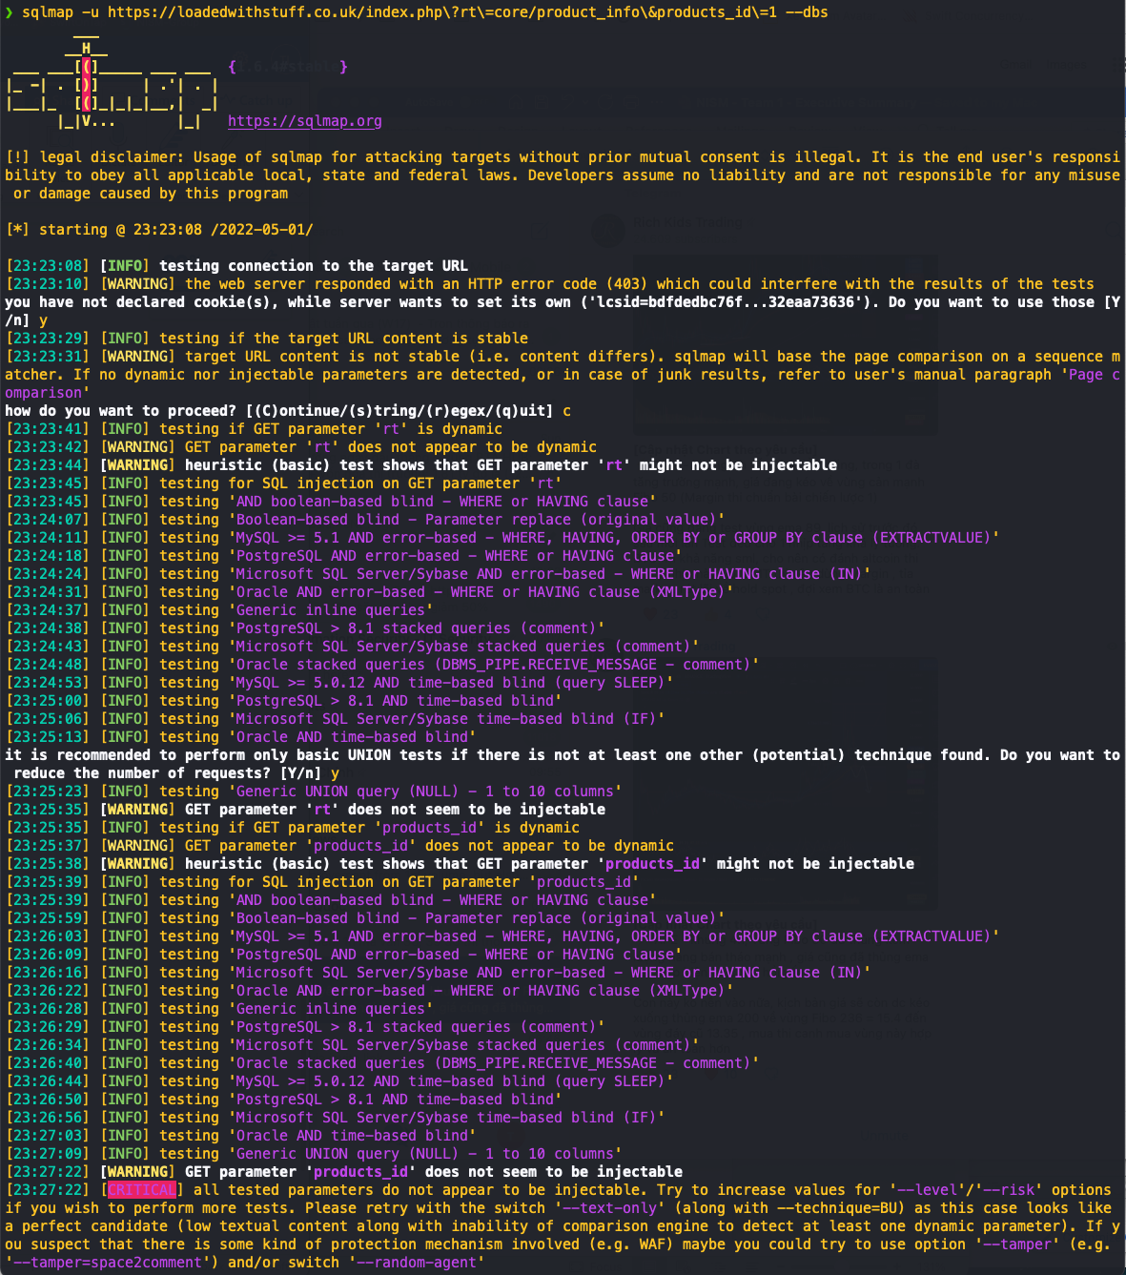

## Appendix D – Nikto scan result

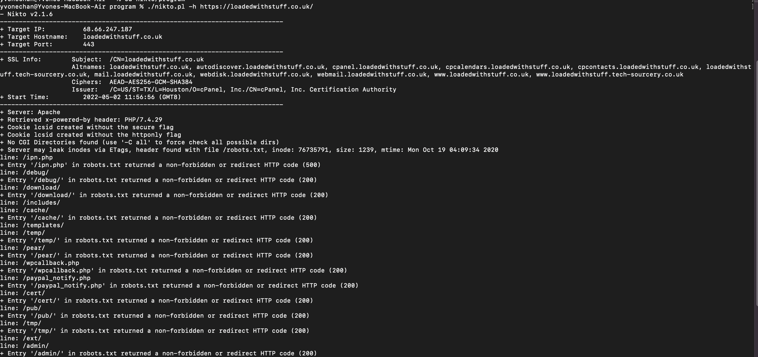

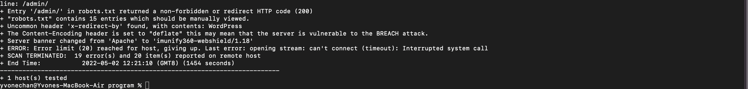

## Appendix E – CPanel is visible to the public

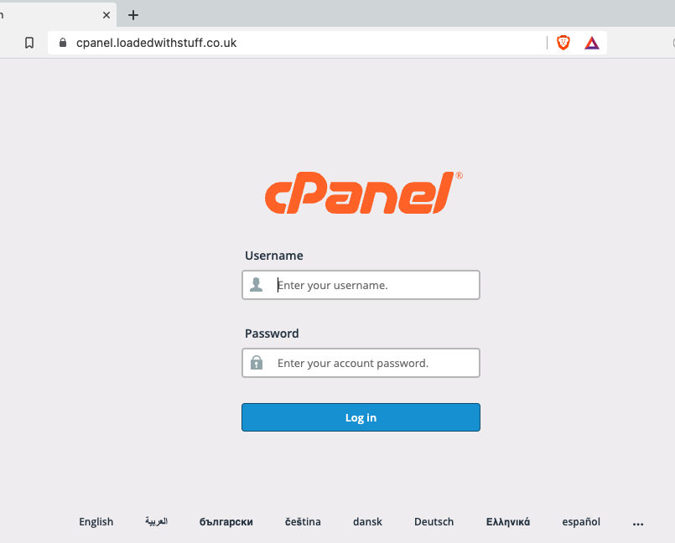

## Appendix F – Webmail is visible to the public

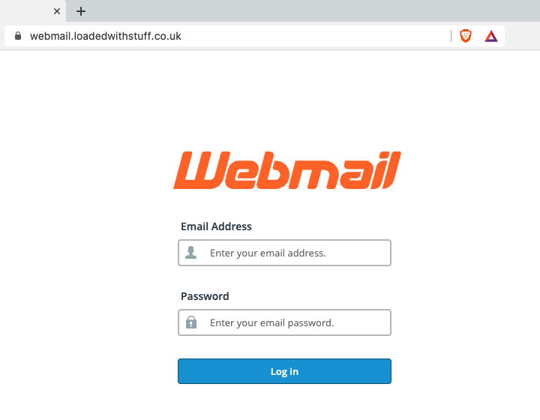

## Appendix G – Burp Suite scan result

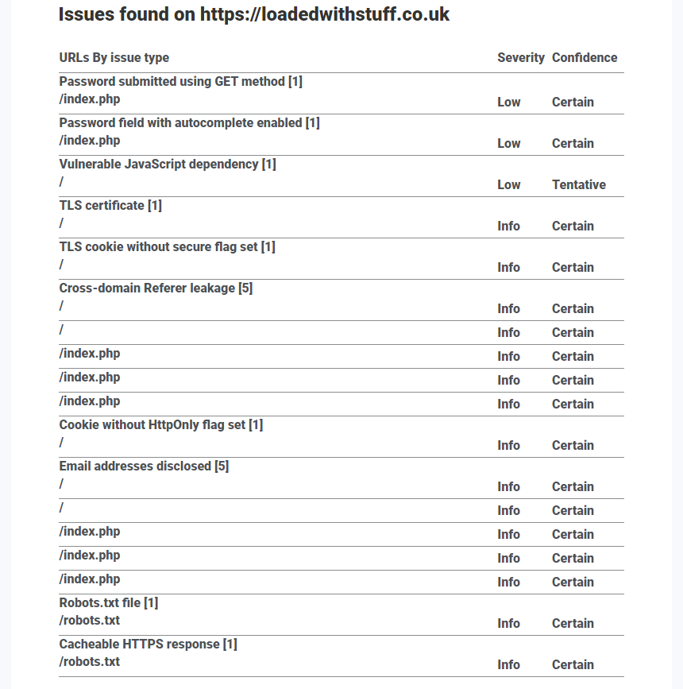

## Appendix H - Absence of Anti-CSRF Tokens

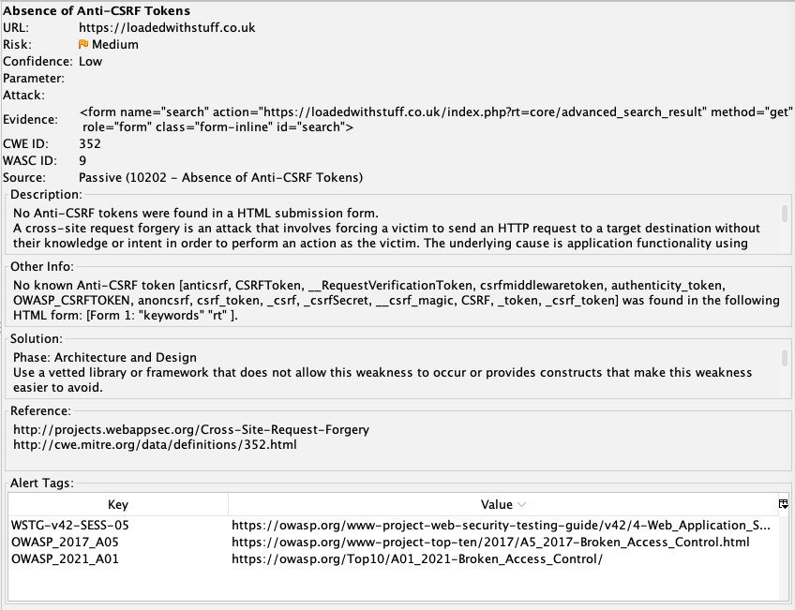

## Appendix I - Content Security Policy (CSP) Header Not Set

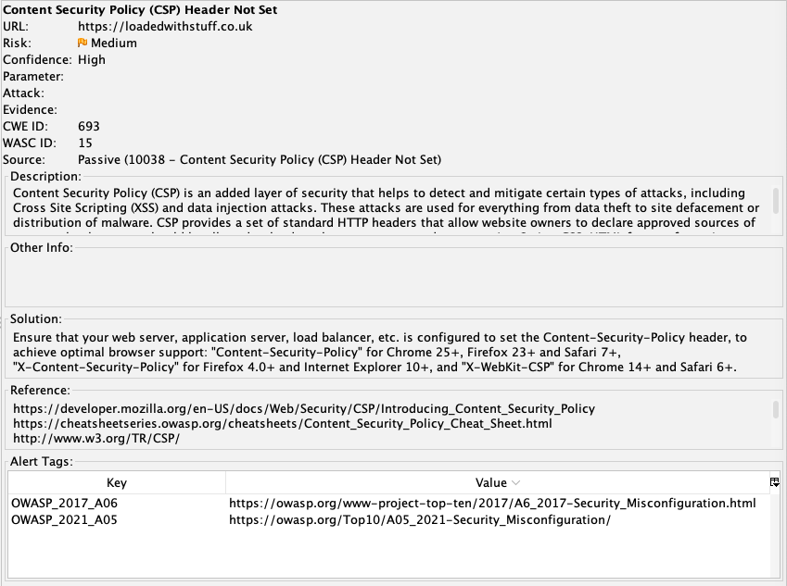

## Appendix J - Vulnerable JS Library

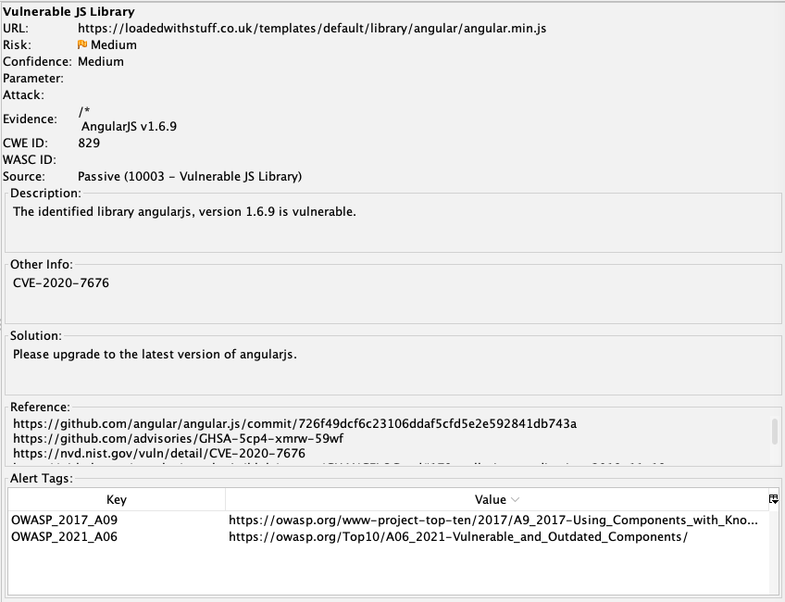

## Appendix K - Application Error Disclosure

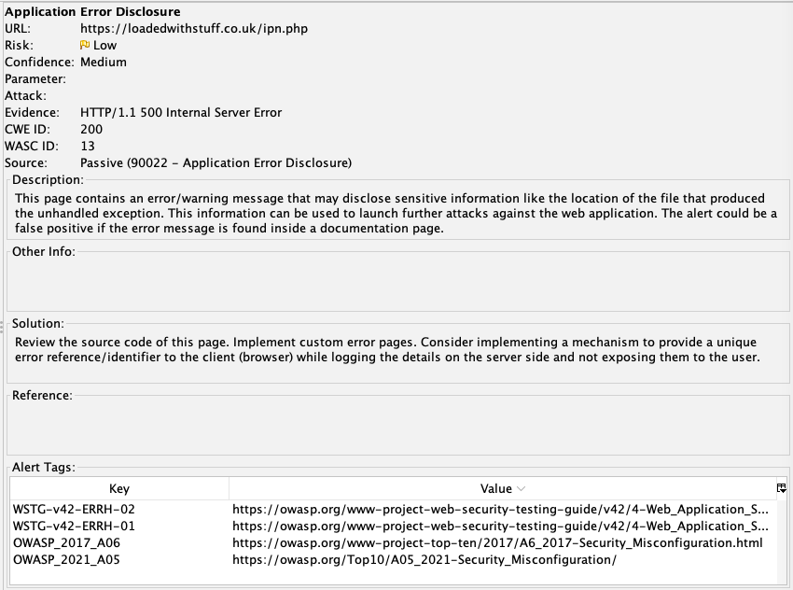

## Appendix L - Cookie without SameSite Attribute

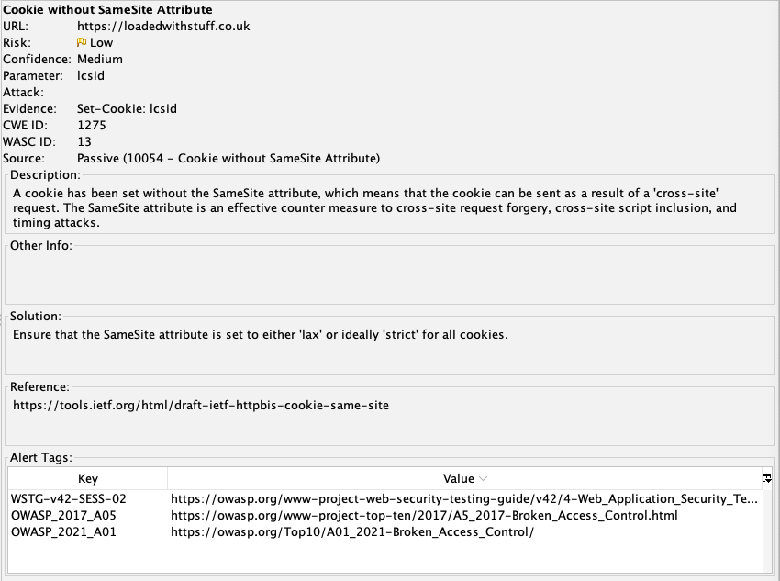

## Appendix M - Server Leaks Information via "X-Powered-By" HTTP Response Header Field(s)

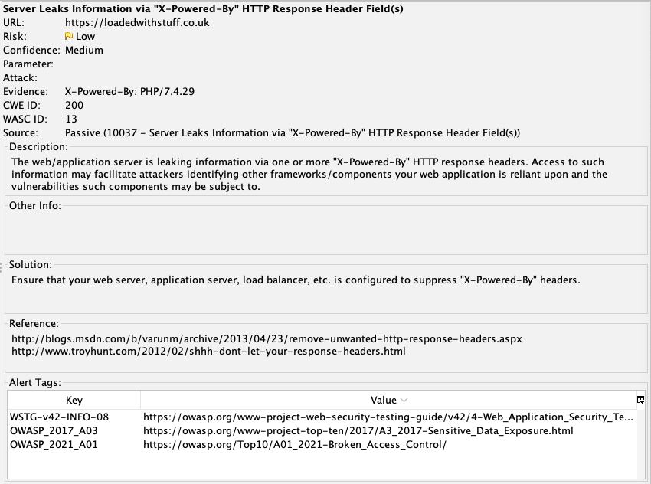

## Appendix N - Timestamp Disclosure

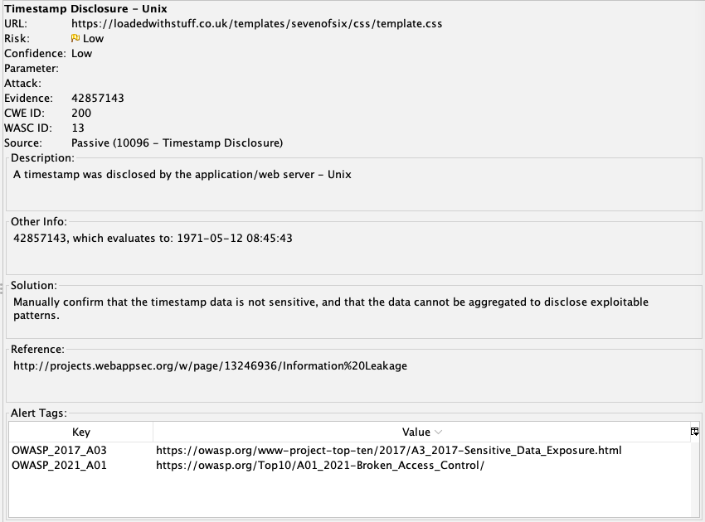

## Appendix O - Port scanning result from Metasploit

